Relationship between SRT, TSS, and Turbidity for Loxahatchee

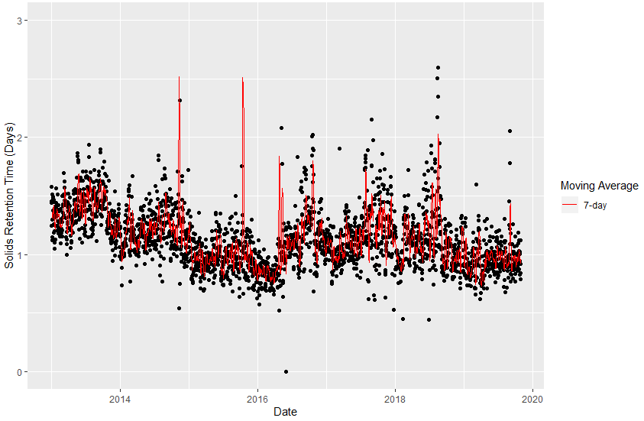

There is no clear trend in solids retention time (SRT), overall. SRT steadily decreases from 2013 to 2016 before increasing until the end of 2016. After 2016, SRT was basically flat over time.

